**Lesson03 Typescript Overview**

**Notes:-**

**1-the way that the html page is called is that with the selector name in the index.html**

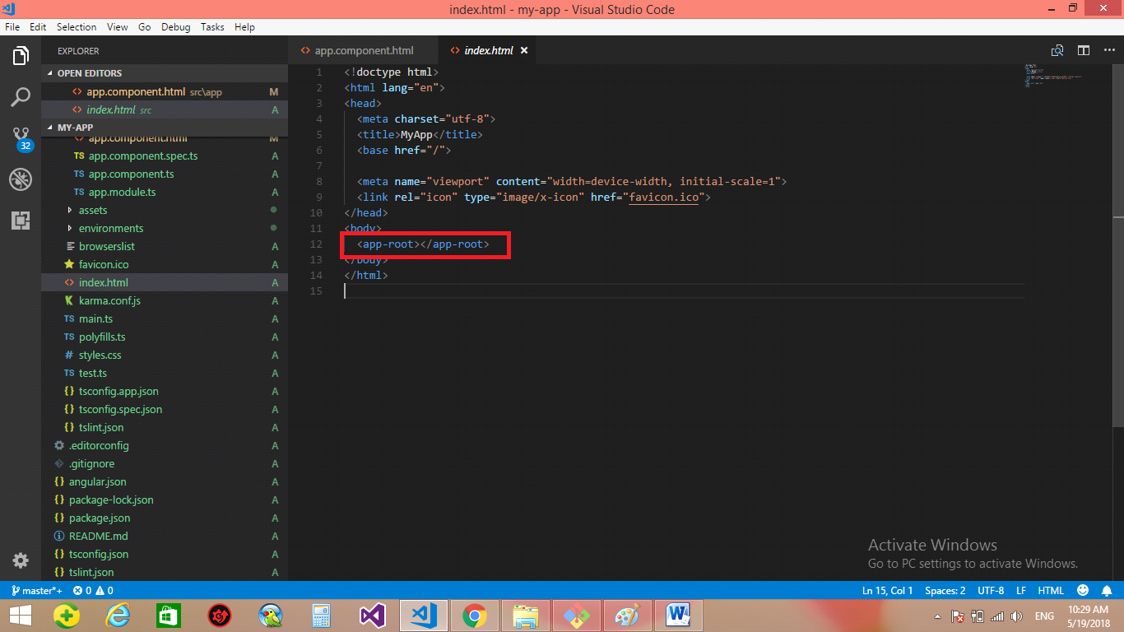

**2-so the index.html search for the app.component.ts then find the @component and execute the match selector by detect the html page path and css path and detect the title and put the reuslt in the**  <app-root></app-root>

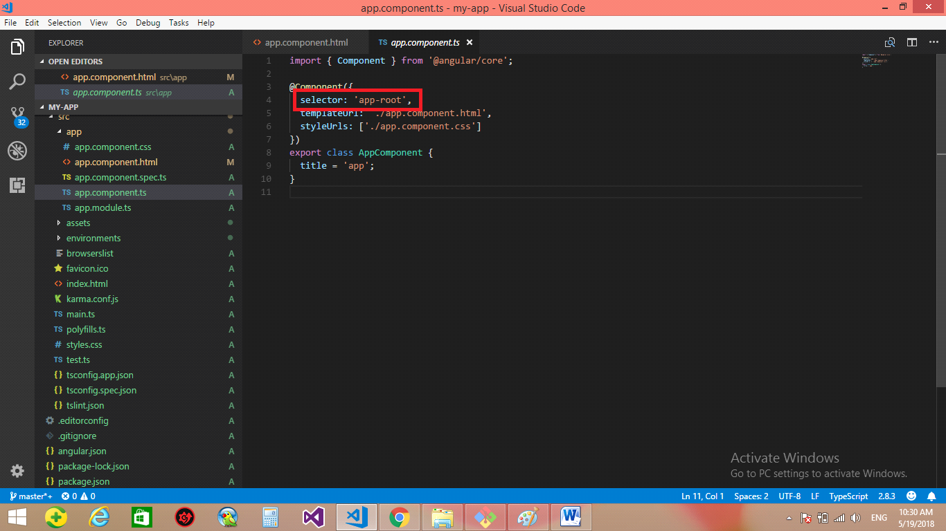

**We see that when we apply the ng –serve –open**

**And then edit the html page and then save it will automatically refresh**

**Note: - if we change the title as the following**

import { Component } from '@angular/core';

@Component({

selector: 'app-root',

templateUrl: './app.component.html',

styleUrls: ['./app.component.css']

})

export class AppComponent {

title = 'Mohammed Enbah';

}

**The Mohammed Enbah will be replace with the app.component.html**

//This is the way that the angular variable will put replace with the {{title}}

<h1>

Welcome to {{ title }}! Hi test

</h1>

**2-we see that the node_modules is the files that the angular need from the node js to execute**

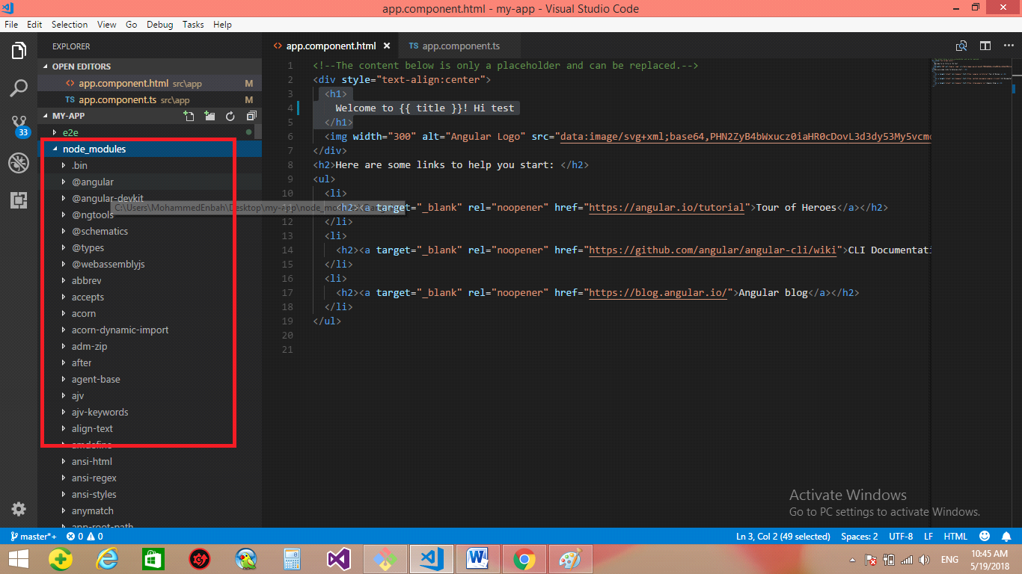

**3-the folder called e2e is called end to end, and it’s responsible for the unit testing**

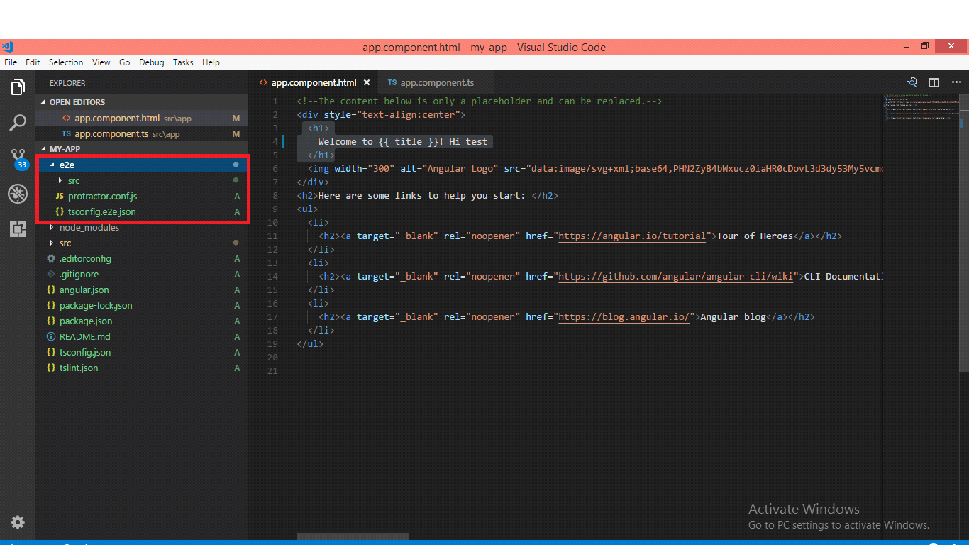

**3-the assets folder is used for storing images**

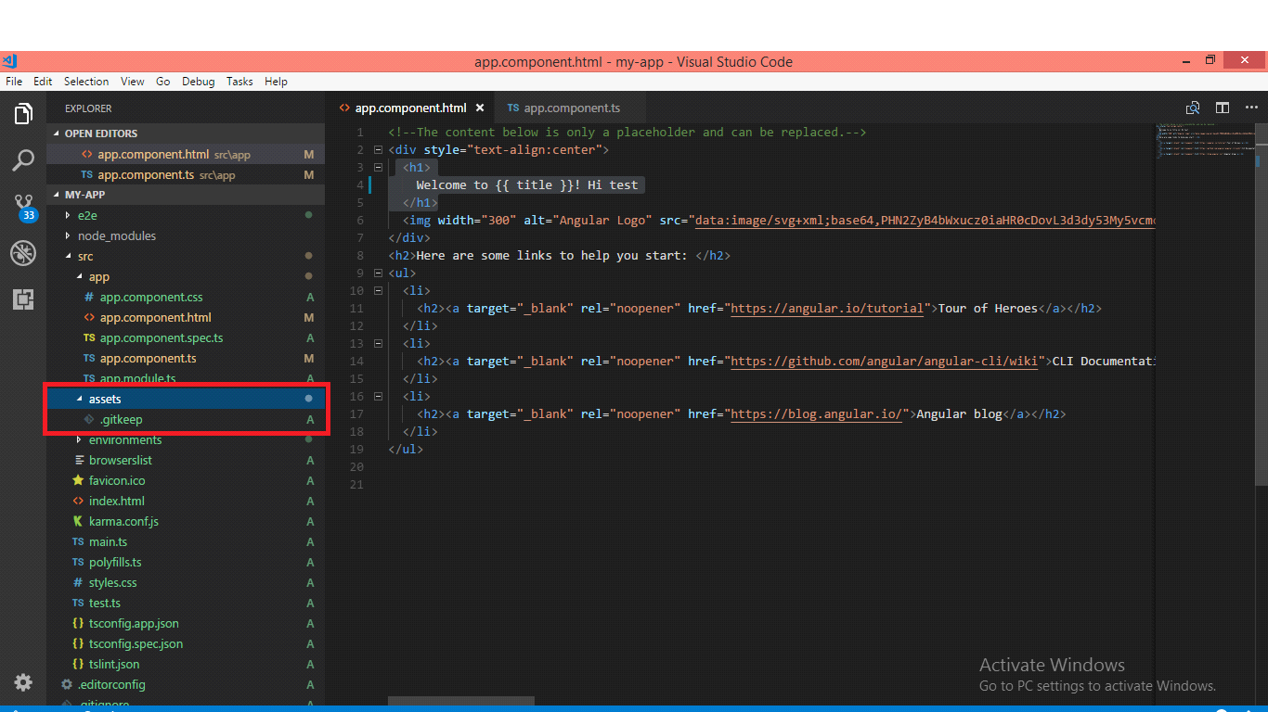

**4-we see in the environment folder it consist the production info for development**

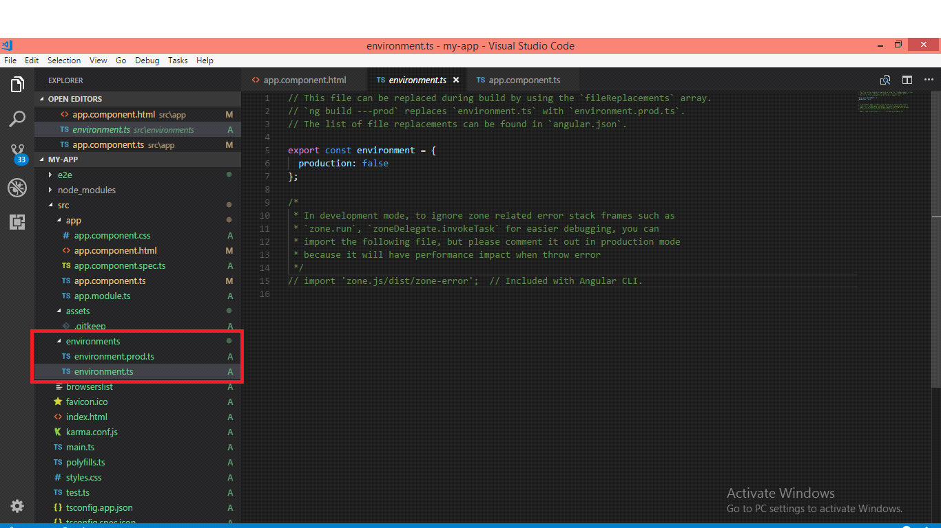

**5-we see in the angular.json it will show the configuration of your application and how it’s works and why it’s begin from the index.html and search inside the src app and search to the app.comopnent.spec.ts**

{

"$schema": "./node_modules/@angular/cli/lib/config/schema.json",

"version": 1,

"newProjectRoot": "projects",

"projects": {

//the name of the porject

"my-app": {

"root": "",

//the root is the src

"sourceRoot": "src",

"projectType": "application",

"prefix": "app",

"schematics": {},

"architect": {

"build": {

"builder": "@angular-devkit/build-angular:browser",

"options": {

//This the path of the make the product for the people

"outputPath": "dist/my-app",

//This is the primary html page

"index": "src/index.html",

//This is the main type Script

"main": "src/main.ts",

"polyfills": "src/polyfills.ts",

"tsConfig": "src/tsconfig.app.json",

//The folders of the images

"assets": [

"src/favicon.ico",

"src/assets"

],

//The Style folder

"styles": [

"src/styles.css"

],

"scripts": []

},

"configurations": {

"production": {

"fileReplacements": [

{

"replace": "src/environments/environment.ts",

"with": "src/environments/environment.prod.ts"

}],

"optimization": true,

"outputHashing": "all",

"sourceMap": false,

"extractCss": true,

"namedChunks": false,

"aot": true,

"extractLicenses": true,

"vendorChunk": false,

"buildOptimizer": true

}}},

"serve": {

"builder": "@angular-devkit/build-angular:dev-server",

"options": {

"browserTarget": "my-app:build"

},

"configurations": {

"production": {

"browserTarget": "my-app:build:production"

}}},

"extract-i18n": {

"builder": "@angular-devkit/build-angular:extract-i18n",

"options": {

"browserTarget": "my-app:build"

}},

"test": {

"builder": "@angular-devkit/build-angular:karma",

"options": {

"main": "src/test.ts",

"polyfills": "src/polyfills.ts",

"tsConfig": "src/tsconfig.spec.json",

"karmaConfig": "src/karma.conf.js",

"styles": [

"src/styles.css"

],

"scripts": [],

"assets": [

"src/favicon.ico",

"src/assets"

]}},

"lint": {

"builder": "@angular-devkit/build-angular:tslint",

"options": {

"tsConfig": [

"src/tsconfig.app.json",

"src/tsconfig.spec.json"

],

"exclude": [

"**/node_modules/**"

]}}}},

"my-app-e2e": {

"root": "e2e/",

"projectType": "application",

"architect": {

"e2e": {

"builder": "@angular-devkit/build-angular:protractor",

"options": {

"protractorConfig": "e2e/protractor.conf.js",

"devServerTarget": "my-app:serve"}},

"lint": {

"builder": "@angular-devkit/build-angular:tslint",

"options": {

"tsConfig": "e2e/tsconfig.e2e.json",

"exclude": [

"**/node_modules/**"

]}}}}},

"defaultProject": "my-app"

}